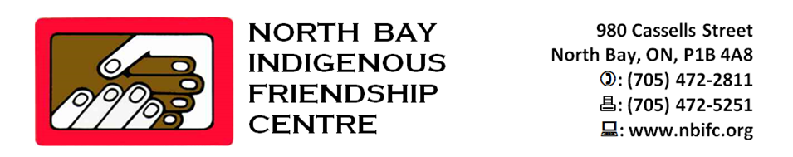

**ABORIGINAL FETAL ALCOHOL SPECTRUM DISORDER (FASD) & CHILD NUTRITION PROGRAM**



**MISSION STATEMENT**

The mission of the North Bay Indigenous Friendship Centre is to improve the quality of life for First Nation, Metis, and Inuit people in the urban environment of North Bay by supporting self-determined activities which encourage equal access and participation in society and which respects Aboriginal Cultural distinctiveness.

The North Bay Indigenous Friendship Centre provides a wide array of programs and services to support Aboriginal people of all ages. An important part of our mandate is to serve as a gathering place for Aboriginal and Non-Aboriginal people.

The centre is a place where aboriginal culture is celebrated friendships are made knowledge skills are shared and good times are enjoyed.

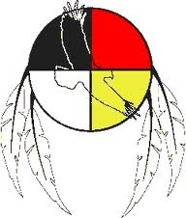

**FASD FACTS**

* NO AMOUNT OF ALCOHO9L IS SAFE DURING PREGNANCY
* FAS CAUSES SERIOUS SOCIAL AND BEHAVIOURAL PROBLEMS
* THERE IS NO CURE FOR FASD
* FASD OFTEN IS DIAGNOSED WITH OTHER DISORDERS
* IT IS A 100% PREVENTABLE DISORDER

As an adult with FASD, it may be a challenge to maintain an independent lifestyle. It is often difficult to stay in school, secure a job or sustain a healthy relationship. There is a potential to becoming a high risk of developing mental health issues, criminal tendencies, substance abuse and unplanned pregnancies.

**THE ABORIGNAL FETAL ALOCOHOL SPECTRUM DISORDER (FASD) AND CHLD NUTRITION PROGRAM**

Raising awareness of drinking during pregnancy also includes nutritional skills providing a healthy well-balanced positive choice to living well.

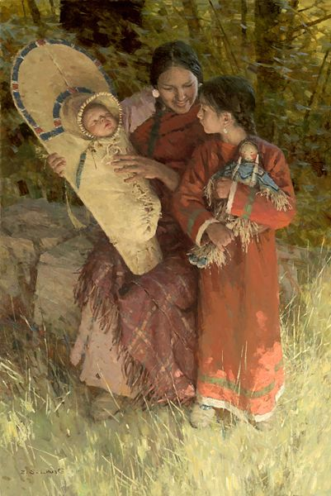

**FASD/FAS/FAE**

A lifetime disability that is preventable. An individual living with this disability faces the risks of developmental delays, learning disabilities, early school dropout, homelessness, inability to stay focused, behavioral challenges, physical disfiguration, short stimulation threshold and other mental illnesses.

**CHILD NUTRITION**

The critical period of growth development for children is birth to 12yrs of age. It is imperative that children adopt healthy eating practices that promote good health.

**“CHILDREN ARE OUR FUTURE, WITHOUT THEM WE HAVE** **NO ONE TO CARRY OUR TEACHINGS**, **OUR HISTORY OR OUR** **LANGUAGE”**

**FOR MORE INFORMATION PLEASE CONTACT:**

**BRENDA ROBERTS**

**PHONE: (705) 472-2811 EXT. 205**

**FAX: (705) 472-5251**

**EMAIL: fasd@nbifc.org**

SERVICES PROVIDED

* ONE ON ONE SUPPORT
* WORKSHOPS
* PRESENTATIONS
* COMMUNITY LAISON
* REFERRALS

**REFERRALS CAN BE MADE TO:**

* ABORIGINAL PRENTAL PROGRAM
* FAS CLINICS
* HEALTHY BABIES HEALTHY CHILDREN
* COUNSELLING
* FAMILY SUPPORT
* HEALTH CARE PROVIDERS