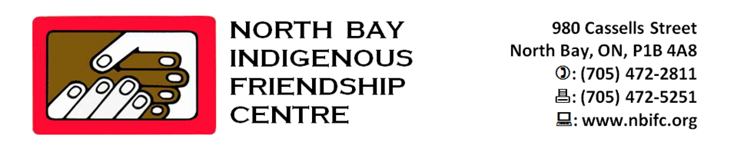
JOB POSTING – FULL TIME
INDIGENOUS CHILDREN’S WELLNESS PROGRAM

STATUS: Permanent Full Time: 35 hours/week
POSITION: Indigenous Children’s Wellness Worker
ACCOUNTABILITY: The worker reports directly to the Executive Director

DUITIES and RESPONSABILITIES:

- Takes personal responsibility to increase cultural sensitivity, awareness and implementation of North Bay Indigenous Friendship Centre’s cultural bundle including foundational teachings and organizational practices in both professional conduct and work-related deliverables.
- Builds, develops and sustains business relationships/strategic partnerships which are mutually beneficial, reciprocal and grounded in trust and respect. It is recognizing we are all interdependent and working towards the common good of the organization.
- Accomplishes established goals, delivers the outcomes required and achieves the results. It includes the efficient and effective use of all resources (time, financial, people and technology).
- Works collaboratively with others and addresses conflict in a win-win productive manner. This includes a mindset of “sharing” with others whether it is knowledge, recognition, information and/or skills. Working towards a common purpose for the good of North Bay Indigenous Friendship Centre and communities of people it serves.
- Effectively delivers information in a transparent, honest and clear manner. It includes actively listening, comprehending and responding appropriately when interacting with people. It is about being respectful when expressing opinion and points of view.
- Work with local stakeholders within indigenous and non-indigenous community service organizations and institutions, as well as community members, to support the goals and objectives of the Friendship Centre.
- To provide one-on-one support to children who are victims of or witnesses to violence.
- To develop a plan of action to meet the needs of Aboriginal children, parent/caregivers referred to the program.
- To facilitate access to, or engage in the development of, appropriate services as required to address the needs of Aboriginal children and their parent/caregiver and/or to meet the requirements laid out by a Child Welfare and/or Legal Authority.
- To integrate with other Friendship Centre programs and externally to meet the holistic needs of the client.
- To ensure the development and implementation of a full range of program services as identified in the Friendship Centres Annual Service Plan.
- To ensure that the Program is grounded in culturally-based community development principles and practices.
- To promote awareness and ensure access to the Program.
- To liaise with community development through advocacy, education and the implementation of local initiatives.
- To promote the development of protocols and referral agreements as appropriate to meet the needs of Aboriginal children and families/caregivers in the community.
- To initiate and participate in care conferences as necessary to ensure the needs of child and parent/caregiver.
- To ensure the maintenance of secure and confidential filing system as required under the File Maintenance Policy of OFIFC.
- To strictly adhere to the Confidentiality Policy as laid-out by the Friendship Centre and OFIFC.
- To provide accurate records and reports of the activities and services.
- To participate in training and evaluation processes to ensure continued growth and development of the Program.
- Maintains and updates professional skills, seek further professional development on topics related to the field.
- Promotes a healthy, safe work environment.
- Performs other duties, related to the position, as assigned by the Executive Director or designate.

EDUCATION/ QUALIFICATIONS:
- Shall possess post-secondary education in Aboriginal social work or related field.
- Knowledge and awareness of Aboriginal culture and history, with particular emphasis on family violence and the relationship to child welfare.
- Ability to work professionally, collaboratively with child welfare agencies in Ontario.
- Strong understanding of the Child and Family Services Act and Ontario Children’s Aid Societies, with particular emphasis on how they impact Aboriginal families.
- Must possess skills and experience in presenting educational workshops and facilitating groups.
- Self-motivated, able to schedule and prioritize work.
- Good judgment, adaptability and willingness to learn.
- Willingness to work flexible hours.
- Excellent interpersonal skills with staff and community members.
- To be knowledgeable of and to work with community agencies and referral sources.
- Establish and maintain priorities, work under stress and deadlines.
- Must have the ability to work as a team player and be capable of coordinating activities with other Friendship Centre Programs.
- Knowledge of the Friendship Centre movement, its aims and objectives.
- Knowledge of the North Bay Indigenous Friendship Centre’s programs and services.
- Strong listening, oral and written communication skills.
- Proficiency in MS Office applications (Word, Excel, Outlook, PowerPoint, etc.,).
- Proficiency in using a database reporting system.
- Ability to collect, analyze and interpret qualitative and/or quantitative data analysis.
- Basic research skills required.
- Minimum of 5 years of demonstrated and related work experience within an Indigenous organization or community.
- Knowledge of Aboriginal cultures.
- Ability to speak Cree and/or Ojibway an asset.
- Current Standard First Aid and Level C CPR; WHMIS; and Food Handler Certificate.
- Excellent knowledge and ability to work proficiently with the company software packages, e-mail and the Internet.
- Experience in working with not-for-profit, provincial and federal funding agencies.
- Must be licensed to drive a motor vehicle, insured to do so in the Province of Ontario and have access to a safe and reliable vehicle.
- Ability to provide a clear Criminal Reference Check and Vulnerable Persons Check.

DEADLINE FOR RESUMES: October 16, 2019 @ 4:00 pm

Please forward cover letter, resume and (3) recent references to:
Kathy Fortin - Executive Director
North Bay Indigenous Friendship Centre
980 Cassells Street
North Bay, ON
P1B 4A6
or
email to: director@nbifc.org

“We would like to thank all interested individuals; however, only those selected for an interview will be contacted. While we encourage individuals of all backgrounds to apply, those of Indigenous descent will be given preference”

