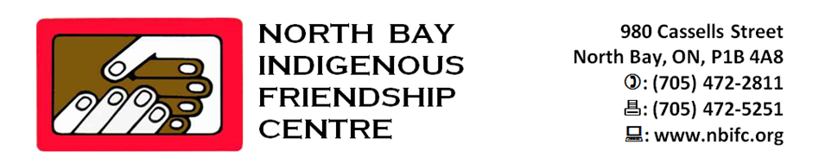

JOB DESCRIPTION
Akwe: GO Coordinator

STATUS: Fulltime 35 hours per week- Short Term Contract
ACCOUNTABILITY: Reports to the Executive Director
Deadline: December 4, 2019 at 4:00 pm

Job Duties and Responsibilities:

- Conduct needs assessment of at-risk children 7-12 years of age and develop a plan to meet the needs of children referred to the Akwe: GO program.
- Ensure the development and implementation of a full range of program activities that will strengthen children’s self esteem, enhance their social skills, and encourage healthy lifestyle choices.
- Ensure that Akwe: GO program activities incorporate traditional cultural teachings and values.
- Provide social supports to address self esteem issues, victimization issues and peer pressures.
- Engage in outreach activities to increase access to culturally appropriate services to children in care and their families, and to include support and education for non Indigenous adoptive and foster parents.
- Promote health and physical development activities to address inter-related health impacts of poverty, diabetes and obesity.
- Increase institutional support for children including school supervision and school suspension supports: development of activities that encourage positive relationships with peers and authority figures: facilitate direct access to educational support services for children involved in the program
- Ensure that resource people and /or Elders are utilized within the programming.
- Refer children to counselling and other services as required.
- Liaise with other community service providers to ensure effective delivery of Akwe: GO program services.
- Ensure that parents and volunteers are utilized in a constructive and positive manner for the benefit of the children and programming.

Qualifications:

- Minimum Social Service diploma and/or 3-5 years relevant work experience
- Knowledge of aboriginal culture and language.
- Knowledge of social, cultural and recreational needs and interests of children and youth.
- Excellent communication skills.
- Excellent facilitation skills.
- Knowledge and experience working with Aboriginal youth.
- Ability to meet deadlines with minimum supervision.
- Good time management and planning skills.
- A valid driver’s licence/drivers abstract
- Standard First Aid/CPR Certificate
- Food Handler Course.
- Criminal records check/vulnerable person check.
- Ability to speak Ojibway or Cree would be an asset.

Please forward cover letter, resume and (3) recent references to:
Kathy Fortin - Executive Director
North Bay Indigenous Friendship Centre
980 Cassells Street
North Bay, ON
P1B 4A6
or
email to: director@nbifc.org

“We would like to thank all interested individuals; however, only those selected for an interview will be contacted. While we encourage individuals of all backgrounds to apply, those of Indigenous descent will be given preference”

